**Cloud Computing**

**UE19CS352**

**6th Semester, Academic Year 2021-22**

Week #: 1 - Serverless Computing with AWS Lambda

Date: 31/1/2022

|  |  |  |
| --- | --- | --- |
| Name :  SUMUKH RAJU BHAT | SRN :  PES1UG19CS519 | Section :  H |

1. a. 2 buckets created

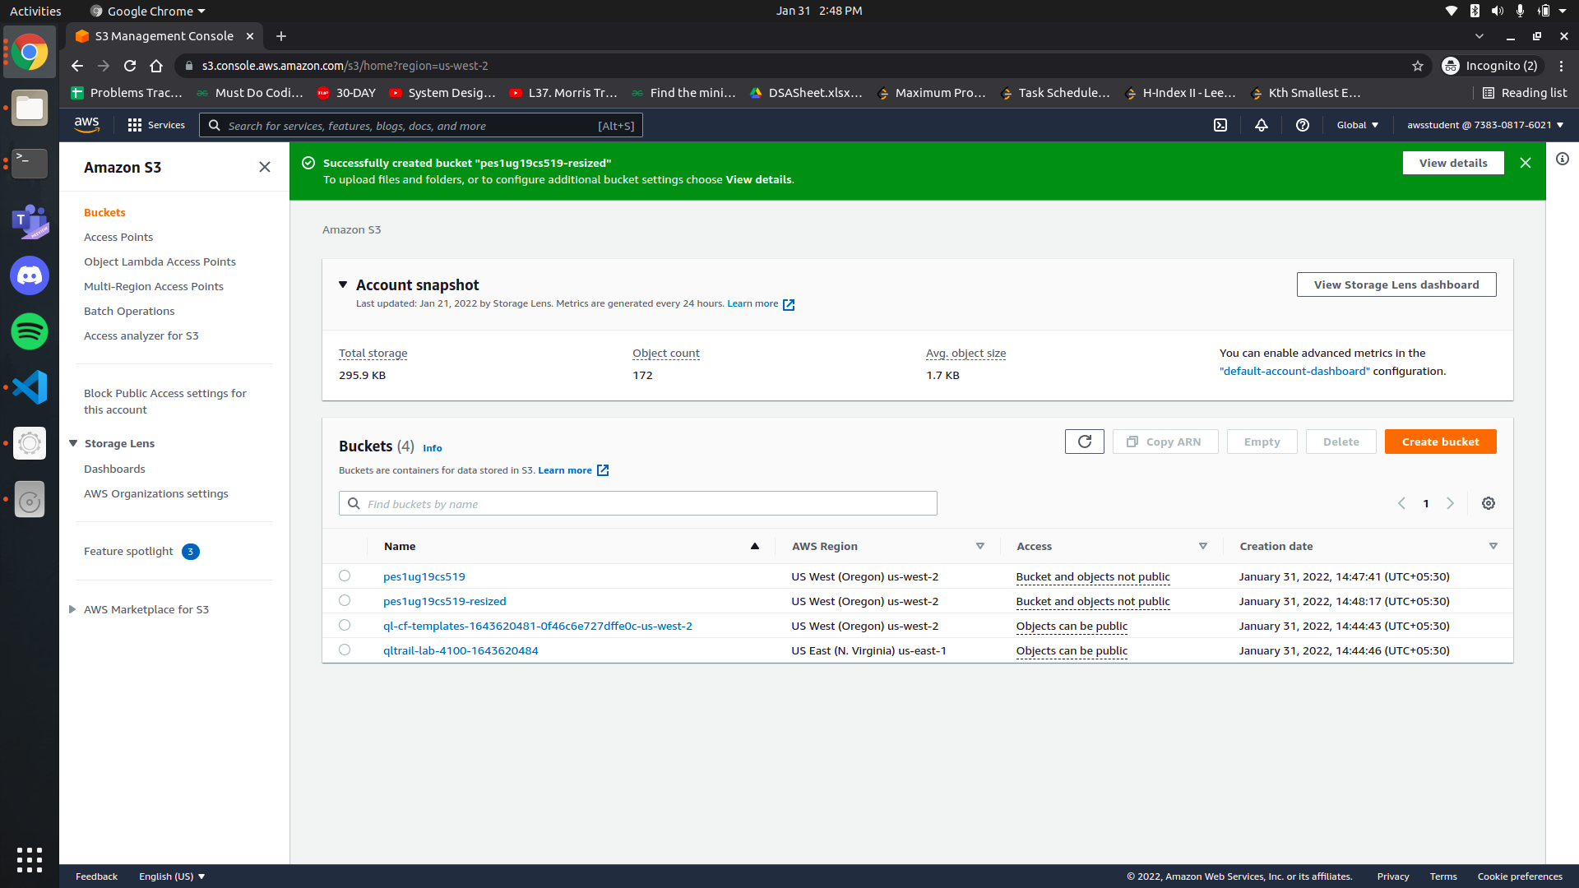

1. b. Successful test run 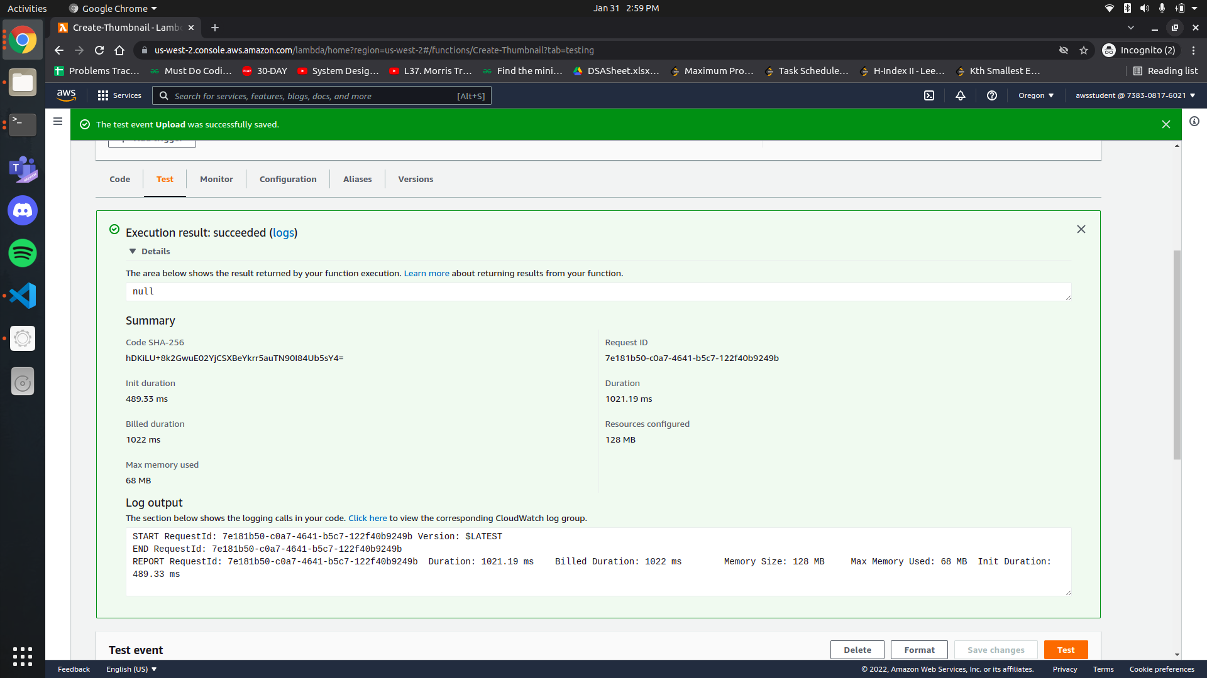
2. c. Thumnail created in resized bucket

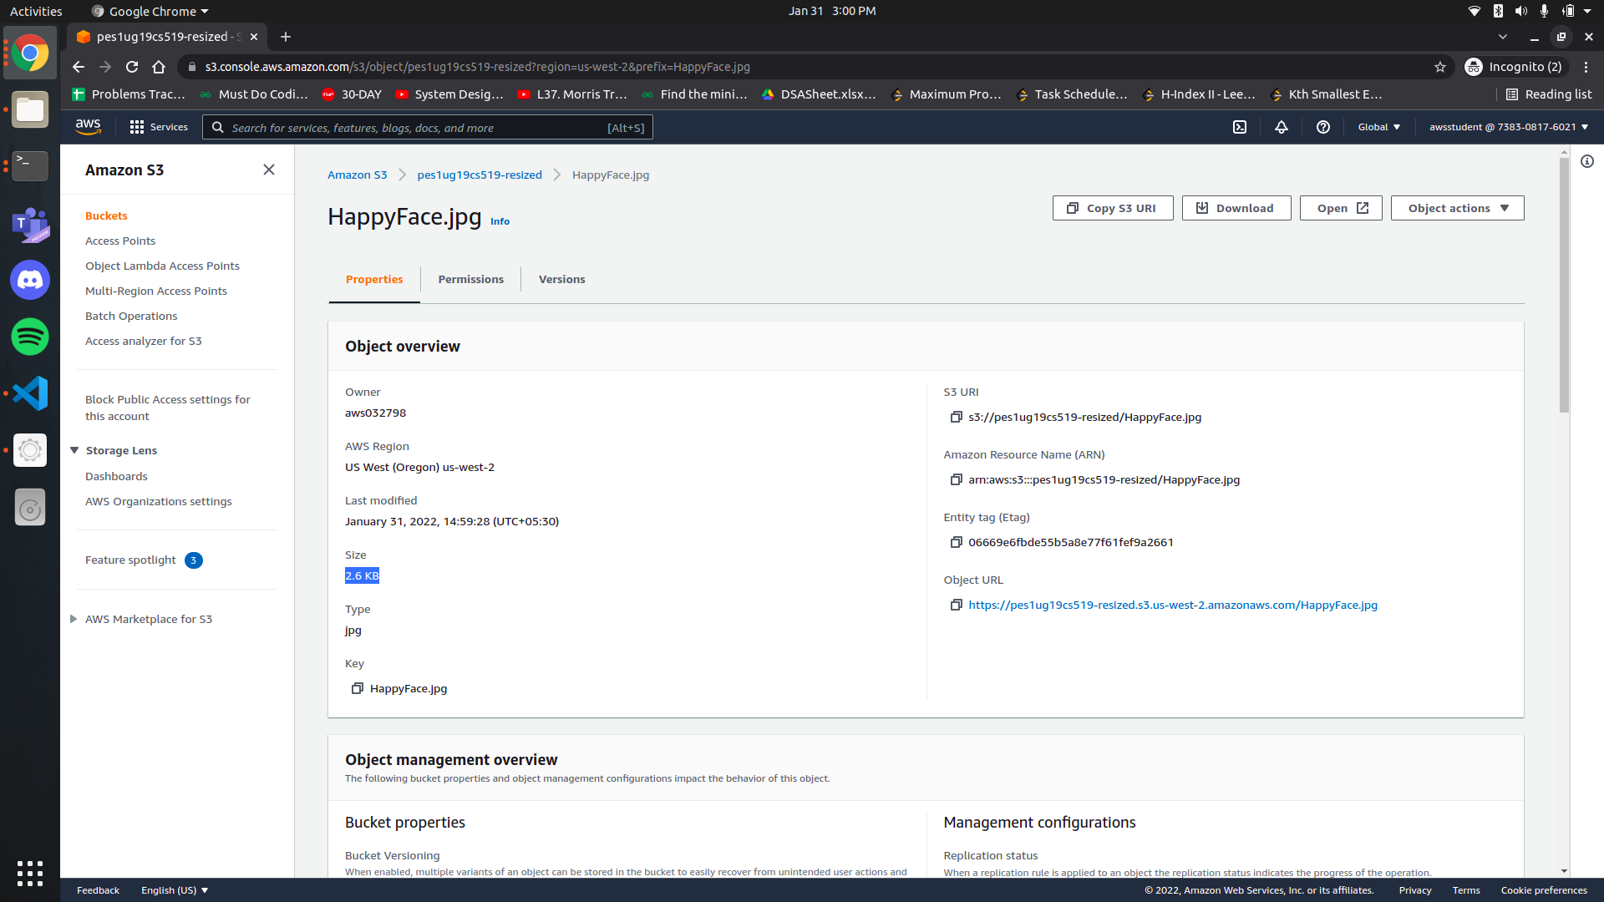

(Proof of resize after downloading)

